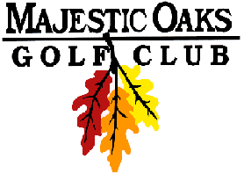

Wednesday Night Final Results
2 Man Best Ball Blind Draw- Gross & Net
Signature Course
July 25th 2018
Gross Team Winners
1st –Rick Vanyo & Jake Jacott Score: 34 $25 per Player
2nd –Jon Walberg & Scott Anderson Score: 36 $15 per Player

Net Team Winners
1st –Jim Leach & Zach Slotness Score :29 $25 per Player
2nd –Jim Weidner & Richard Cooper Score: 30 $15 per Player

CLOSEST TO PIN
Hole #12 – Paul Thompson $20
Hole #15 – Greg Beane $20

Gross Skins
Flight 1- $15/skin
3 on #18 Scott Anderson
2 on #12 Kurt Cassidy
3 on #14 Rick Vanyo

Flight 2- $10/skin
5 on #13 Matt Prebil
4 on #17 Matt Prebil
3 on #14 Zach Slotness
5 on #16 Zach Slotness
2 on #15 Greg Beane

Net Skins
Flight 1- $15/skin
2 on #18 Scott Anderson
3 on #13 Zach Milligan
2 on #15 Jayson Honor
Flight 2- $12/skin
1 on #15 Greg Beane
2 on #14 Zach Slotness
3 on #16 Zach Slotness
2 on #18 Jim Leach
*won in scorecard playoff Last 9, Last 6, Last 3, Last

