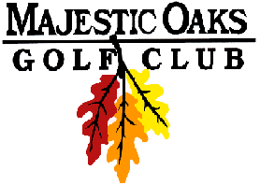

Wednesday Night Final Results
2 Man Best Ball Blind Draw- Gross & Net
Signature Course
May 30th 2018
Gross Team Winners
1st –Ben Haubach & Craig Weston Score: 37 $22 per Player
2nd – Mark Roy & Zach Slotness Score: 38 $15 per Player

Net Team Winners
1st –Pat Arnason & Matt Prebil Score: 28* $22 per Player
2nd –Andy Stromgren & Jim Weller Score: 28 $15 per Player

CLOSEST TO PIN
Hole #4 – Pat Arnason $20
Hole #8 – Greg Beane $20

Gross Skins
Flight 1- $12/skin
3 on #2 Chad Gutenkauf
3 on #3 Chad Gutenkauf
4 on #6 Ben Haubach
2 on #8 Craig Weston
Flight 2- $45/skin
3 on #9 Mark Roy
Net Skins
Flight 1- $12/skin
3 on #6 Ben Haubach
3 on #9 Ben Haubach
2 on #3 Chad Gutenkauf
2 on #8 Craig Weston
Flight 2- $15/skin
2 on #2 Andy Stromgren
1 on #8 Greg Beane
2 on #9 Mark Roy
*won in scorecard playoff Last 9, Last 6, Last 3, Last 1

